**Contents:**

|  |  |
| --- | --- |
| A picture of a winding road and trees  Decoding Alex Frieberg social media presence  [Document subtitle] | Abstract  Alex Frieberg is tech influencer who engages with its audience through videos on topics under data analytics, this document focuses on social media presence of Alex Frieberg specifically on Linkedin & Youtube  Presented by- Moin Chini |

1. **Introduction**
2. **Alex Frieberg**
3. **Why choose Alex Frieberg**
4. **Insights of Linkedin profile**
   1. **Linkedin Profile**
   2. **Top ten videos with highest engagement**
   3. **Time posted** 
      1. **Time of the day vs number of posts**
      2. **Time of the day vs number of posts vs likes**
      3. **Time of the day vs number of posts vs comments**
   4. **Number of posts vs month**
   5. **Number of posts vs posts type**
   6. **Number of reposts vs posts type**
5. **Insights of Youtube profile** 
   1. **Youtube Profile**
   2. **Top ten videos with highest engagement**
   3. **Number of videos vs month**
   4. **views vs month**
   5. **Time of the day vs videos**
   6. **Promotional vs non-promotional videos**
   7. **Views vs type of videos**
6. **Conclusion**
7. **Introduction:** This report highlights different aspects of social media presence of Alex Frieberg particularly focusing on Linkedin & Youtube. Different graphs on several parameters are used in this report to analyse Alex’s strategy of posting depending on time, type of content etc to analyse engagement it has attracted over a period of time. This report also suggests patterns, Alex is following to post new content which is useful to draw strategy in order to attract engagement
8. **Who is Alex Frieberg:** Alex Frieberg is a Data Analyst by qualification and is socially active on various social media platforms such as Linkedin, Youtube & Instagram. He posts on several topics such as personal & technical skills important for someone aspiring data analyst as a career. Additionally, he shares topics & frequently asked questions during interviews. He discusses external factors affecting job market in data analysis such as artificial intelligence.

He is a founder & manages a website named analysebuilder.com which offers paid courses on different topics under data analysis such SQL, python, pandas etc.

1. **Why choose Alex Frieberg?** Alex is one of leading Data content creator on social media platforms & has garnered popularity in short span of around 3 years since he started being active on public platforms. Alex’s content is consumed by young aspirants who are considering data analytics as a career. I have personally gone through his videos at the time of evaluating data analytics as my career which has helped me to get a clear picture of what skills this job demands, what to expect from this career & how to pursue to be a data analyst.

Videos on his channel focuses on topics which are essential to learn to get a sound knowledge in data analytics. He has long corporate experience working as a data analyst which he shares often to highlight real time scenarios. He makes a point to discuss external factors which influence the demand in job market like artificial intelligence & global trend towards data analytics domain.

Alex’s work & online presence is closely related to aspiring data analysts like me and studying & analysing Alex’s work will help to enhance knowledge about data

1. **Linkedin profile:** Alex Frieberg is most active on Linkedin & posts regularly to better engage with its audience. Alex uses graphs, images, polls, texts, videos, video links and website links for posting content. Key features of his Linkedin account are as follows:

* Alex have 273k followers on Linkedin
* Alex is active on Linkedin since 1st April 2017
* Alex’s profile is verified by Linkedin & have access to premium membership
* Average length of videos on Linkedin is 30 minutes & 42 seconds with average views for each video is 193.87k
  1. 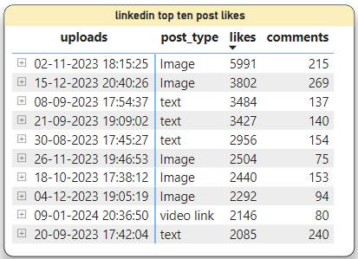**Top ten videos with highest engagement on Linkedin:** This section focuses on top ten videos which attracted most engagement. Likes & comments responded to particular posts will be analysed to conclude the videos which performed better than others. Also, this section will help to analyse content type, users responded to most. Point to be noted, since the data is available for last 5 months, all the analysis discussed below shall be within mentioned time frame

A table is shared below to highlight top ten Linkedin posts that attracted highest number of likes & comments sorted in descending order. Key findings are discussed below:

* Most number of likes is noticed for the post uploaded on 2nd November 2023 which is an image
* Majority of the posts are image in top 10 liked videos followed by text & video link, this shows that image posts are most popular among the audience
* It is learned from the analysis that maximum number of the posts are uploaded between 6pm & 8pm, probably Alex have noticed the engagement pattern which indicated as evening time is when most people are active on Linkedin
* Posts which have majority number of likes have in most cases higher number of comments, this is expected since these posts have received most engagement

Alex has posted graphs, images, polls, texts, videos, video links & website links in among 100 posts made in last 5 months, but images & texts found the highest engagement on Linkedin. Since most of the content is shared in form of texts & images, this may also be the reason of their popularity. Engagement on videos posted recent time is better than ones posted before that suggests response to posts is getting better with every new post

* 1. **Time posted:** This section highlights posts posted online at the given time of the day. This is to focus how different time of the day affects the posts engagement
     1. 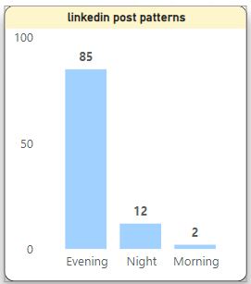**Time vs number of posts:** 85% of posts were posted at evening followed by 12% & at night & remaining 2% in the morning

Since number of views for any given post on Linkedin is not public & only admin have access to it, but can assumed looking at the pattern of posts made public. Alex may have found out that the engagement on posts is most in the evening time, so preferably he chose to make most out of it at this time. Also, given people usually are busy with work & mostly find more time after work on evenings, it supports the idea of highest engagement at evening

* + 1. 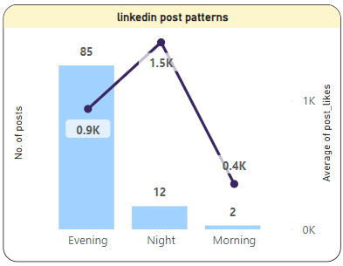**Time vs number of posts vs likes:** Bar chart shown in this section highlights the number of posts posted at any given time of the day and average number of likes it has attracted

Interestingly, though number of posts are highest at the evening time, around 85% but average likes received to posts is highest for posts at night. Average likes to the 85% posts at the evening time is 900, for night posts which is just 12% posts, average likes are almost double to 1500 and the morning post of 2% have average likes of 400

* + 1. 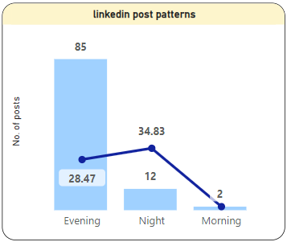**Time vs number of posts vs reposts:** Line & stacked column chart below shows relation between time of the day, number of posts & number of reposts. Similar pattern is observed that of the section discussed above

Average number of reposts is higher for posts made online at night though number of posts posted online is highest in evening

Number of reposts is 28.47 for 85 posts at evening whereas it is 34.83 for 12 posts at night

Clearly, night posts have higher reposted even though majority of posts are from evening. Same pattern is noticed in the previous section but the difference is small comparatively

This section concludes that majority of posts were uploaded online between 5pm & 7pm but the difference the responses in terms of likes & reposts is not determined by number of posts. Infact, with just 12% of posts at the evening has attracted more likes & reposts on average

* 1. **Number of posts vs month:** This section focuses on number of posts posted online on monthly basis. The line graph that displays number of posts as per the month is shown below. Key observations are mention below:

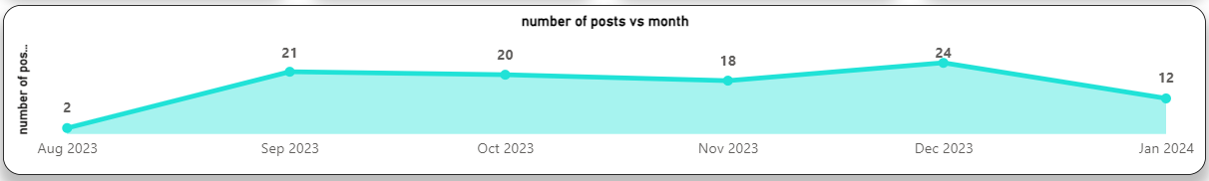

* Most number of posts were uploaded on Linkedin by Alex in the month of December ie. 24 and least number of videos were posted in the month of August.
* But since, data for full month of the August is not available, November is the month with least number of videos posted.
* January 2024 saw 12 new videos uploaded online though the data is available only till 11th, but the ratio of posts seems better than any other month

It is noticed that the average number of videos posted every month is around 20 which breakdowns to 2 videos for every three days. It can be seen that number of videos posted every month are quite consistent avoiding large gap in minimum number of videos uploaded per month to maximum number of videos uploaded per month. Consistent posting in certain time intervals is important to keep users engage ultimately building loyalty & trust factor

* 1. **Number of posts vs post type:** This section focuses on type of posts Alex has posted on his Linkedin handle. Analysis could be done to find out favourable post type Alex uses to share his knowledge on the subject and to connect to its audience. Bar chart shown below showcases number of posts Alex posted for certain post types

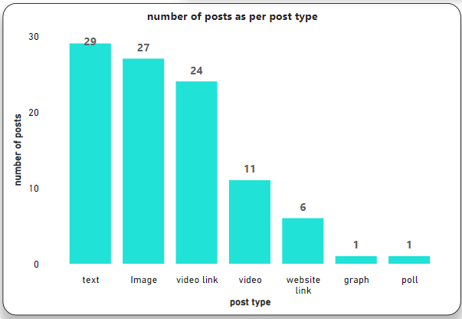

* Text comprises 29% of total posts. Alex uses text posts to share insights about topics which aspirants commonly misses which are sometimes asked in the interview. Alex have also used text posts to share updated job market requirements and factors affecting the demand
* Image comprises 27% of share of the total posts to share tiny tricks & tips useful in data analysis to make a job easy. It is generally conveyed in one sentence
* Next, video links that closely follows at 24% share of posts of total posts. These posts are generally informative videos that covers several topics of different subjects under data analytics
* Other posts have minor presence compared to overall posts in the timeline that is videos at 11%, website link at 6% and graphs & polls at 1% each

Alex uses the different mode of posts depending on type of information he wish to share, as per analysis text, images & video links are mostly used that comprises 80% of total posts

* 1. **Number of reposts vs post type**: This section focuses on number of reposts done per post type. This section will be similar as previous one to analyse the engagement of the end users. Key observations made are as follows:

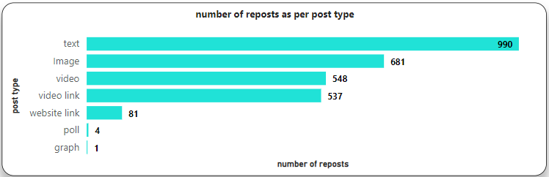

* Highest number of reposts are done in text format which is around 990 which is closely followed by 681 reposts in image format. Since, most of the posts in the timeline are posts in text & image formats, so major number of reposts in this category is not surprising, Alex uses text & images to convey short messages on particular topics useful under data analytics
* 548 reposts are done in video format & 537 in video link which are generally long videos covering topics in details
* Rest reposts forms a minor share such as website link that is 81 and poll & graph 1 each

It appears Alex have found a suitable way to engage with audience in form of texts, images and videos which is highly preferred by its audience

1. **Youtube profile:** Alex Frieberg is consistent in posting videos on his Youtube channel and uses this platform to share long video to teach several topics under data analytics and short videos to cover small topics under any subject quite similar to text & images in Linkedin. Few key findings from you tube profile is discussed below:

* Alex have a Youtube account under a username ‘Alex the analyst’ and he has posted 275 long videos so far which has attracted 28 million views in total
* Total number of subscribers to his channel are 666k
* He has joined the youtube channel on 8th January 2020 and have a verified account
* The average length of videos on his channel is 30 minutes & 42 seconds and average views on his videos is 193.87k

Alex is data analytics coach and you tube is the single most important platform to share his learnings to mass. Alex has a large number of people following him on youtube is considered as one of most popular influencers on social media to talk on data analytics which justifies his average views on youtube videos which is quite high for edtech influencers

* 1. **Top ten videos with highest engagement on Youtube:** This section discusses about the top ten best performing videos on his youtube channel under different categories

The table shows top ten videos with most views & likes. Few key points to analyse this table is as follows

* 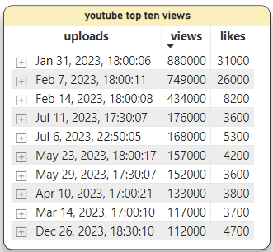All videos in top ten were posted in the year 2023 & not any previous years, this indicates that viewership to Alex’s post has increased in 2023 compared to previous years
* 9 out of 10 videos are posted at evening between 5pm to 6pm, this indicates that people are most active on Youtube during evening, Alex may have strategically posted most of his videos in evening to aim most engagement on his posts
* Most popular video was posted on 31st January 2023 which gathered 8.8 million views with least viewed video was posted on 26th December 2023 which attracted 1.12 million views
* Amount of likes to the video have almost same trend as views to the video

Alex videos are getting popular as per time proceeds as analysis suggests since videos posted in 2024 are experiencing more engagement than videos in 2023. All of the videos which made in top 10 are posted between 5pm & 6pm. Alex regularly upload videos online on this time, this suggests engagement is highest between 5pm & 6pm

* 1. **Number of videos vs month:** This section highlights frequency of videos posted online as per the month. The data in this section only considers long videos & not short video or reels. Below is line chart of number of videos posted per month

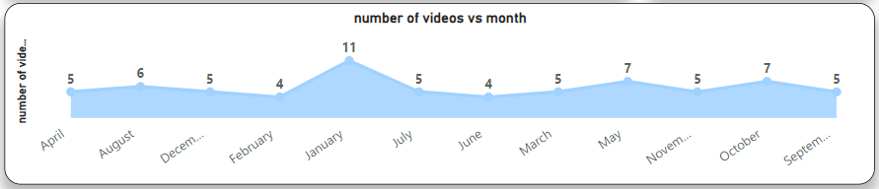

* January have seen highest number of videos posted which is 11 while February & June has lowest number of videos posted online.
* On an average, 5 to 7 videos are posted every month

Frequency of videos uploaded is quite consistent except for the month of January which has 11 videos uploaded. Consistency in uploading videos at regular intervals has importantly helped Alex to build a loyal viewers and subscribers

* 1. **Views vs months:** This section discusses total number of views on videos sorted by month. This will give idea on popularity of videos among users as per month. This section serves purpose pretty much similar to the previous section. Line chart is shared below to describe views trends as per month. Observations on the line chart are mention below:

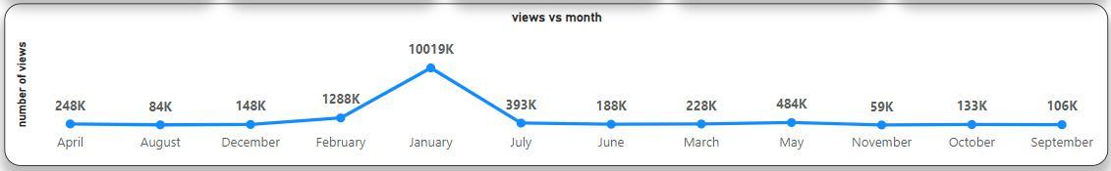

* January has seen most engagement with over a million views which justifies since January has also recorded maximum number of new videos uploads
* November has recorded lowest viewership which is about 59k views

In most of the cases, views are directly proportional to number of videos which is the case in this section too. Engagement pattern is pretty similar to the one noticed at the previous section. Since Alex have uploaded videos consistently on regular intervals, accordingly, the views are consistent too

* 1. 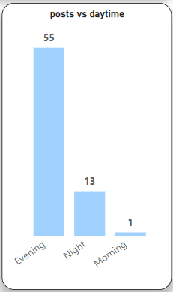 **Time of the day vs videos:** This section highlights patterns of videos posted online by Alex at different time period of the day & chart below shows the same for analysis. Key findings are below:
* 85% of videos are posted in the evening whereas 13% are posted at night and only 1% in the afternoon
* Alex may have found the pattern where viewers are most active throughout the day which is evening in this case

This also makes sense since most of the people usually finish work and have more time to use social media at evenings

* 1. 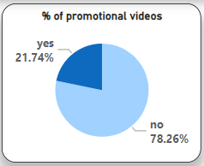**Promotional vs non-promotional videos:** This section is to focus on types of videos Alex has posted on his youtube channel. Alex have added promotions to earn revenue from his videos or in few cases have not opted for it. Below pie chart shows percent wise share of promotional & non-promotional videos

As pie chart suggests, only 21.74% of videos are promotional of all videos uploaded while majority of videos, 78.26% videos does not have promotional advertisement attached to it. Alex may have opted for non-advertisement since all videos contains tech info and are used by learners, this may have led Alex to opt majorly for non-promotional videos

* 1. **Views vs type of videos:** This section discusses viewers preference of the video type. Alex have uploaded two types of videos viz. promotional & non-promotional videos. This analysis would help Alex to identify users preference and can accordingly strategize type of videos to upload. Below is bar graph explaining the same

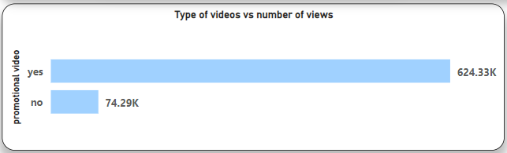

Promotional videos have attracted 624.33k views whereas non-promotional videos have 74.29k views. Usually, most of creators opt for promotional videos since it creates revenue for creators, but Alex have not attached promotions to majority of his videos. On contrast to number of video uploads as per category, majority of views can be noticed to promotional videos compared to non-promotional videos

1. **Conclusions:** Alex have a major presence on Linkedin and Youtube which he uses to share content revolving around data analytics. Few important conclusions are stated below

* Linkedin, majorly he uses to share small text or image to share short messages & video links of his content on you tube.Alex uses youtube to share long videos on topics under data analytics & short reels to share short similar to text & images he shares on Linkedin
* He occasionally shares about the analystbuilder.com, a website founded & managed by him on his Linkedin & youtube channel. This website offers courses & bundles for data analytics aspirants
* Alex started posting content on social media in the middle of covid pandemic since he losses a job after working for long in corporate. Because of his quality content, in a short span of around three years, he has garnered good numbers of subscribers & loyal viewers which makes him among one of top content creators in data analytics on social media
* As per the analysis, there is an increase in traffic on posts that uploaded recently compared to ones in past. This shows popularity of content is growing
* Since more people are opting online to learn & also at the time when data analytics promises a growing demand in future, increasing number of subscribers & content consumers are set to grow in future on Alex’s Linkedin & youtube handle